Test with synthetic data
r = 0.101, rho = r/0.12 = 0.84, gammaRate
analytical solution
bins = 20, i.e. 400 (r,rho) testing – 54 mins; one (r,rho) takes 8 second
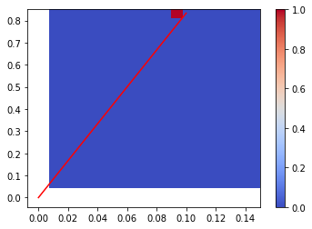

simulation method – likelihood
bins = 50, i.e. 50 (r,rho) testing – 102 mins; one (r,rho) takes 2 mins
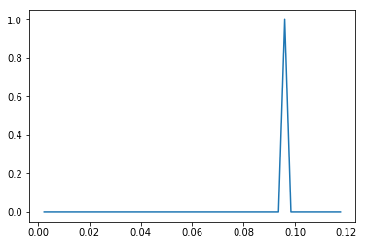
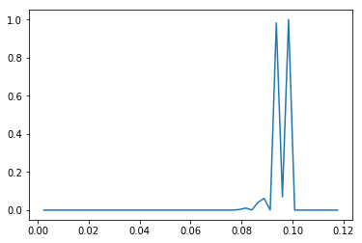
exp gamma

simulation method – distance
bins = 10, i.e. 100 (r,rho) testing – 92 mins; one (r,rho) takes 55 second
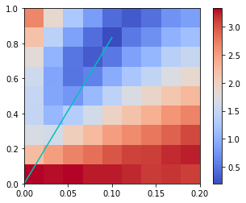
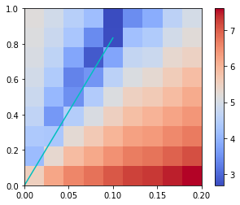
ks quantile (loged distance)

pyABC – 56 mins
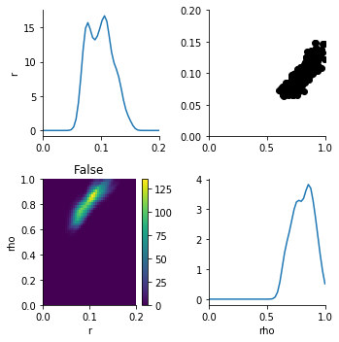
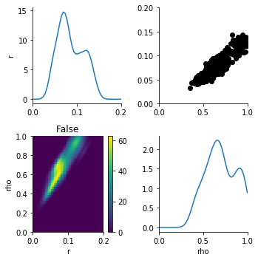
ks quantile

r = 0.060, rho = 0.060/0.12 = 0.5, expRate
analytical solution simulation method – likelihood
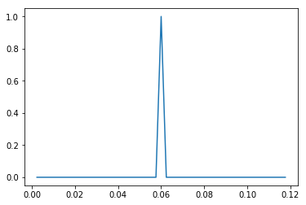
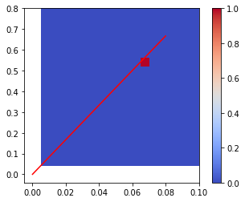

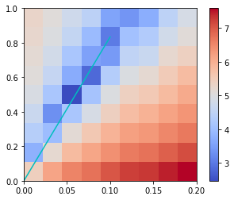
simulation method – distance
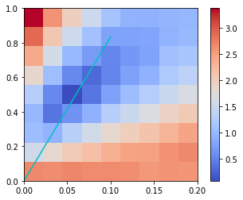
ks quantile

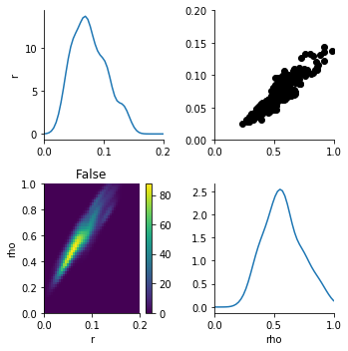
pyABC
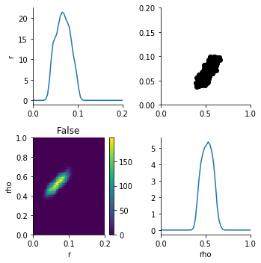
ks quantile

r = 0.085, rho = 0.085/0.12 = 0.71, expRate
analytical solution simulation method – likelihood
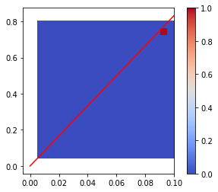
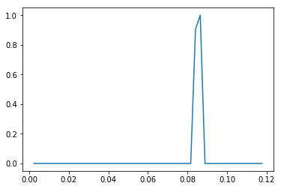

simulation method – distance
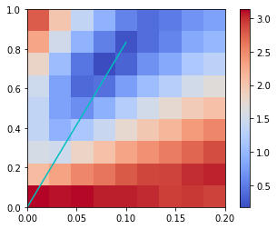
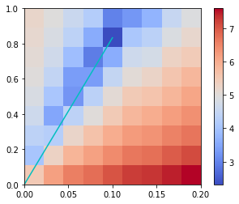
ks quantile

pyABC
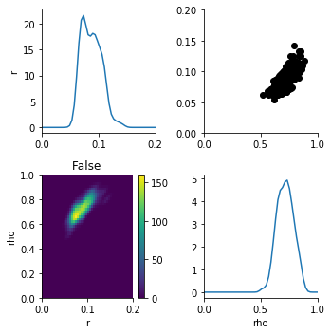
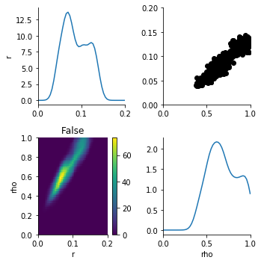
ks quantile

r = 0.045, rho = 0.045/0.12 = 0.375, expRate
analytical solution simulation method – likelihood
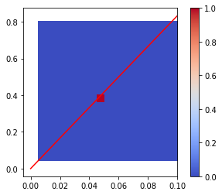
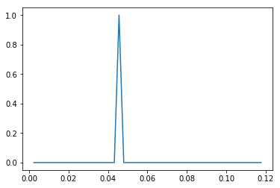

simulation method – distance
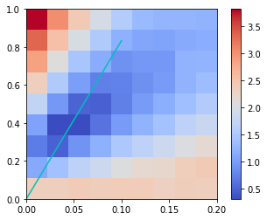
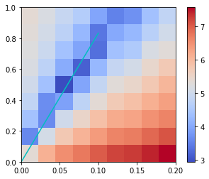
ks quantile

pyABC
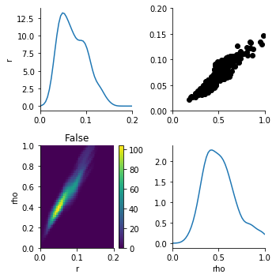
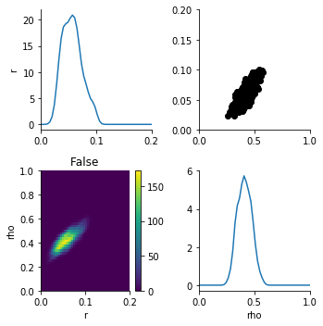
ks quantile

